St. George Serbian Orthodox Church
5830 Glenview Avenue
Cincinnati, OH 45224, USA

Very Reverend Petar Petrovic Divine Liturgy: 10:30 AM
Church: (513)542-4452 Feast Day Liturgy: 8:00 AM
Mobil: (513)544-7481 Confession: before Divine Liturgy
Email: blagoslov@cinci.rr.com Church School: 10:30 AM
Home page: www.stgeorgecinci.org

Samaritan Sunday June 2, 2013

HOLY BREAD: Protinitza Gordana Petrovic READER: Adam Meador
LUNCH SPONSORS :
COLLECTION & USHERS: Men of St. George
ALTAR HELPERS: Zoran Zivadinovic

WELCOME! We would like to welcome our visitors with us today. We invite you to follow the Divine Liturgy, which begins on page 28 of the Blue Service Books. WE REGRET THAT THE DIVISION OF CHIRISTIANITY DOES NOT PERMIT US TO OFFER COMMUNION TO NON-ORTHODOX OR THOSE OF THE CHURCH WHO ARE UNPREPARED. However, please come forward at the end of the Divine Liturgy to venerate the Cross and receive the Antidoron - blessed bread - as a token of love and fellowship. PLEASE RESPECT THE HOLY LITURGY BY ARRIVING TO CHURCH ON TIME AND PARTAKING IN THE LITURGY TOGETHER WITH THE ENTIRE CONGREGATION. The prosperity of our Church is in your hands! Please remember to leave your contact information by signing the guest book before you leave the Church.

EPISTLE:( Acts 11:19-26, 29-30) Now they which were scattered abroad upon the persecution that arose about Stephen travelled as far as Phenice, and Cyprus, and Antioch, preaching the word to none but unto the Jews only. And some of them were men of Cyprus and Cyrene, which, when they were come to Antioch, spake unto the Grecians, preaching the LORD Jesus. And the hand of the Lord was with them: and a great number believed, and turned unto the Lord. Then tidings of these things came unto the ears of the church which was in Jerusalem: and they sent forth Barnabas, that he should go as far as Antioch. Who, when he came, and had seen the grace of God, was glad, and exhorted them all, that with purpose of heart they would cleave unto the Lord. For he was a good man, and full of the Holy Ghost and of faith: and much people was added unto the Lord. Then departed Barnabas to Tarsus, for to seek Saul: And when he had found him, he brought him unto Antioch. And it came to pass, that a whole year they assembled themselves with the church, and taught much people. And the disciples were called Christians first in Antioch. Then the disciples, every man according to his ability, determined to send relief unto the brethren which dwelt in Judaea: Which also they did, and sent it to the elders by the hands of Barnabas and Saul.

GOSPEL: (John 4:5-42) Then cometh he to a city of Samaria, which is called Sychar, near to the parcel of ground that Jacob gave to his son Joseph. Now Jacob's well was there. Jesus therefore, being wearied with his journey, sat thus on the well: and it was about the sixth hour. There cometh a woman of Samaria to draw water: Jesus saith unto her, Give me to drink. (For his disciples were gone away unto the city to buy meat.) Then saith the woman of Samaria unto him, How is it that thou, being a Jew, askest drink of me, which am a woman of Samaria? for the Jews have no dealings with the Samaritans. Jesus answered and said unto her, If thou knewest the gift of God, and who it is that saith to thee, Give me to drink; thou wouldest have asked of him, and he would have given thee living water. The woman saith unto him, Sir, thou hast nothing to draw with, and the well is deep: from whence then hast thou that living water? Art thou greater than our father Jacob, which gave us the well, and drank thereof himself, and his children, and his cattle? Jesus answered and said unto her, Whosoever drinketh of this water shall thirst again: But whosoever drinketh of the water that I shall give him shall never thirst; but the water that I shall give him shall be in him a well of water springing up into everlasting life. The woman saith unto him, Sir, give me this water, that I thirst not, neither come hither to draw. Jesus saith unto her, Go, call thy husband, and come hither. The woman answered and said, I have no husband. Jesus said unto her, Thou hast well said, I have no husband: For thou hast had five husbands; and he whom thou now hast is not thy husband: in that saidst thou truly. The woman saith unto him, Sir, I perceive that thou art a prophet. Our fathers worshipped in this mountain; and ye say, that in Jerusalem is the place where men ought to worship. Jesus saith unto her, Woman, believe me, the hour cometh, when ye shall neither in this mountain, nor yet at Jerusalem, worship the Father. Ye worship ye know not what: we know what we worship: for salvation is of the Jews.
23 But the hour cometh, and now is, when the true worshippers shall worship the Father in spirit and in truth: for the Father seeketh such to worship him. God is a Spirit: and they that worship him must worship him in spirit and in truth. The woman saith unto him, I know that Messias cometh, which is called Christ: when he is come, he will tell us all things. Jesus saith unto her, I that speak unto thee am he. And upon this came his disciples, and marvelled that he talked with the woman: yet no man said, What seekest thou? or, Why talkest thou with her? The woman then left her waterpot, and went her way into the city, and saith to the men, Come, see a man, which told me all things that ever I did: is not this the Christ? Then they went out of the city, and came unto him. In the mean while his disciples prayed him, saying, Master, eat. But he said unto them, I have meat to eat that ye know not of. Therefore said the disciples one to another, Hath any man brought him ought to eat? Jesus saith unto them, My meat is to do the will of him that sent me, and to finish his work. Say not ye, There are yet four months, and then cometh harvest? behold, I say unto you, Lift up your eyes, and look on the fields; for they are white already to harvest. And he that reapeth receiveth wages, and gathereth fruit unto life eternal: that both he that soweth and he that reapeth may rejoice together. And herein is that saying true, One soweth, and another reapeth. I sent you to reap that whereon ye bestowed no labour: other men laboured, and ye are entered into their labours. And many of the Samaritans of that city believed on him for the saying of the woman, which testified, He told me all that ever I did. So when the Samaritans were come unto him, they besought him that he would tarry with them: and he abode there two days. And many more believed because of his own word; And said unto the woman, Now we believe, not because of thy saying: for we have heard him ourselves, and know that this is indeed the Christ, the Saviour of the world.

REMEMBER IN YOUR PRAYERS

HEALTH OF: Geneva Jokich, Jennie Pjanich, Zora Droca, Spaso Droca, Heather Komnenovic, Ninko Stakic, Ranko Tepsic, Stacy, Irma Riordan, DEPARTED: +Stanisa Bojic, +Ruzica Jovanovic; Ionel Dumitru.PRAY FOR THE CHRISTIANS THROUGHOUT THE WORLD.Pastoral Visitations: Ranko Tepsic;
TODAY: ICE CREAM PARTY AT 12:00 NOON
HUMANITARIAN PICNIC FOR HEART TRANSPLANT FOR TIJANA OGNJANOVIC
MONDAY June 03 Sts.Constantine and Helen
Divine Liturgy at 08:00.a.m.
SUNDAY June 09 Divine Liturgy at 10:30.a.m.
THURSDAY June 13 The Ascension of Jesus Christ
Divine Liturgy at 08:00.a.m.
SUNDAY June 16 Divine Liturgy at 10:30.a.m.
SUNDAY June 23 PENTECOST
Divine Liturgy at 10:30.a.m.
FRIDAJ June 28 Divine Liturgy at 8:00.a.m.

SUNDAY June 30 Divine Liturgy at 10:30.a.m.

MAKE PLANS IN YOUR CALENDAR
June 2, 2013
CHARITY PICNIC
FOR HEART TRANSPLATATION for GIRL TIJANA OGNJANOVIĆ in Houston.

Friday June 28, 2013 "VIDOVDAN"

MEMORIAL SERVICE will be held immediately after the Divine Liturgy, which begins in 8.00.a.m.

June 28, 29, 30
SERBIAN BOOTH AT THE GREEK FESTIVAL PANEGYRI
This 3 days our church will be selling Kebabs(CEVAPCICI) at the Greek Festival PANEGYRI.
We expect your help to make this Festival more successful.
For more information, call Dimitrije Jovic chairman at
(513) 205 -8371.

ST. PETER AND PAUL FAST: St .Peter and Paul Fast begins July 1

OLIVE OIL FOR VIGIL LAMPS FOR CHURCH AND ALTAR:

We need Olive Oil for Vigil Lamps for Church and Altar. If you want to donate, please inform the priest or personally bring the Oil to the Church.

Sunday is a day that should be given to the Lord and the Church with our participations at the Holy Liturgy

St. George Serbian Orthodox Church
WEEKLY BULLETIN

June 2, 2013
Stewardship Reflection
CHRIST IS RISEN!
INDEED HE IS RISEN!
The Fifth Sunday of Pascha
June 2, 2013

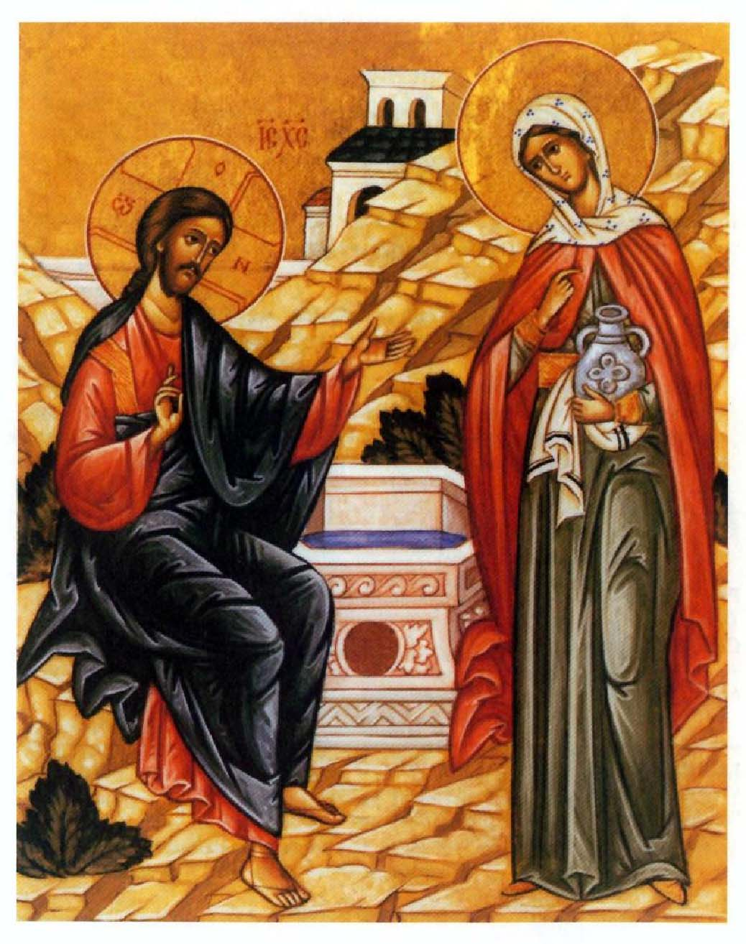
What is Orthodox Christian Stewardship?
Orthodox Christian Stewardship is...
Learning how to be a responsible and concerned caretaker of Christ's Church; it is learning how to enjoy Church life and be happy in Church work., for in Her dwells the fullness of the Spirit of God.
Our active commitment to use all our Time, Talent and Treasure for the benefit of humankind in grateful acknowledgment of Christ's redeeming love.
2 Corinthians 9:7 - Each of you should give what you have decided in your heart to give, not reluctantly or under compulsion, for God loves a cheerful giver.
Caring for the needs of others.
Offering one's self to God as He offered Himself to us.
What a person does after saying "I believe...", as proof of that belief.
Devotion and service to God and His Church as persons, as families, as a diocese and as Church universal.
The theme that we find throughout Stewardship is care... care for our Church, care of our people, care for our children, care for the elderly and care for how we conduct ourselves. Caring requires a commitment and focus - one that mirrors the care that God our Father has for us.
As the summer months approach, please continue to support your Church as a faithful Steward.

Fill out the "STEWARDSHIP" form for 2013. Please give your time and talents!

