St. George Serbian Orthodox Church
5830 Glenview Avenue
Cincinnati, OH 45224, USA

Very Reverend Petar Petrović Divine Liturgy: 10:30 AM
Church: (513)542-4452 Feast Day Liturgy: 8:00 AM
Mobil: (513)544-7481 Confession: before Divine Liturgy
Email: blagoslov@cinci.rr.com Church School: 10:30 AM
Home page: www.stgeorgecinci.org

29th Sunday after Pentecost January 12th, 2014

HOLY BREAD: Protinica Gordana Petrović READER:Marko Petrovic
Cake & Coffee Sponsors: KSS
COLLECTION & USHERS: Marko Petrovic
ALTAR HELPERS: Steven Sajkic, Michael Nikola Miladinovic,Peter Kuprinov,Marko Petrovic

WELCOME! We would like to welcome our visitors with us today. We invite you to follow the Divine Liturgy, which begins on page 28 of the Blue Service Books. WE REGRET THAT THE DIVISION OF CHIRISTIANITY DOES NOT PERMIT US TO OFFER COMMUNION TO NON-ORTHODOX OR THOSE OF THE CHURCH WHO ARE UNPREPARED. However, please come forward at the end of the Divine Liturgy to venerate the Cross and receive the Antidoron - blessed bread - as a token of love and fellowship. PLEASE RESPECT THE HOLY LITURGY BY ARRIVING TO CHURCH ON TIME AND PARTAKING IN THE LITURGY TOGETHER WITH THE ENTIRE CONGREGATION. The prosperity of our Church is in your hands! Please remember to leave your contact information by signing the guest book before you leave the Church.

EPISTLE: Galatians 1:11-19- But I certify you, brethren, that the gospel which was preached of me is not after man. For I neither received it of man, neither was I taught it, but by the revelation of Jesus Christ. For ye have heard of my conversation in time past in the Jews' religion, how that beyond measure I persecuted the church of God, and wasted it: And profited in the Jews' religion above many my equals in mine own nation, being more exceedingly zealous of the traditions of my fathers. But when it pleased God, who separated me from my mother's womb, and called me by his grace, To reveal his Son in me, that I might preach him among the heathen; immediately I conferred not with flesh and blood: Neither went I up to Jerusalem to them which were apostles before me; but I went into Arabia, and returned again unto Damascus.
Then after three years I went up to Jerusalem to see Peter, and abode with him fifteen days. But other of the apostles saw I none, save James the Lord's brother.
GOSPEL-Matthew 2:13-23 -And when they were departed, behold, the angel of the Lord appeareth to Joseph in a dream, saying, Arise, and take the young child and his mother, and flee into Egypt, and be thou there until I bring thee word: for Herod will seek the young child to destroy him. When he arose, he took the young child and his mother by night, and departed into Egypt: And was there until the death of Herod: that it might be fulfilled which was spoken of the Lord by the prophet, saying, Out of Egypt have I called my son. Then Herod, when he saw that he was mocked of the wise men, was exceeding wroth, and sent forth, and slew all the children that were in Bethlehem, and in all the coasts thereof, from two years old and under, according to the time which he had diligently enquired of the wise men. Then was fulfilled that which was spoken by Jeremy the prophet, saying, In Rama was there a voice heard, lamentation, and weeping, and great mourning, Rachel weeping for her children, and would not be comforted, because they are not. But when Herod was dead, behold, an angel of the Lord appeareth in a dream to Joseph in Egypt, Saying, Arise, and take the young child and his mother, and go into the land of Israel: for they are dead which sought the young child's life. And he arose, and took the young child and his mother, and came into the land of Israel. But when he heard that Archelaus did reign in Judaea in the room of his father Herod, he was afraid to go thither: notwithstanding, being warned of God in a dream, he turned aside into the parts of Galilee: And he came and dwelt in a city called Nazareth: that it might be fulfilled which was spoken by the prophets, He shall be called a Nazarene.
----------------------------------------------------------------------------------------------------------------
REMEMBER IN YOUR PRAYERS-HEALTH OF: Jennie Pjanich, Zora Droca, Spaso Droca, Heather Komnenović, Stacy, Irma Riordan, Daniel Pană, Jill Dragon Sandy, Cedomir Djokovic, Miroslav Helbich, Iman Shyam, Joe Mishurda,Sherri Sokolovich.
----------------------------------------------------------------------------------------
SPONSORS FOR LUNCHES , CAKE AND COFFEE FOR January & February

We are asking all who are willing to please be a good steward and volunteer your time and treasure to be a sponsor for coffee hour or lunch.
-----------------------------------------------------------------------------------------
DATES TO REMEMBER:

-Tuesday -January 14th-Circumcision of our Lord-St. Basil the Great(Serbian New Year)-Divine Liturgy at 8:00.am
-Saturday -January 18th-Feast of the Holy Cross(Fasting)Divine Liturgy at 8:00.am
-Sunday -January 19th-Teophany- Divine Liturgy at 10:30.am BLESSING OF WATER -
-Sunday January 26th -ST.SAVA CELEBRATION-Divine Liturgy at 10.30.am.
-Monday -January 27th -St.Sava-Divine Liturgy at 8:00.am
---------------------------------------------------------------------------------
HOMILY-on the Kingdom of the saints
But the saints of the most High shall take the Kingdom and possess the Kingdom for ever, even for ever and ever (Daniel 7:18).
Abased and oppressed in the kingdoms of the world, the saints will reign eternally in the Kingdom of Heaven. The last on earth, they will rejoice as the first in heaven. Hungry, thirsty, barefoot and naked in the transitory kingdoms, they will be like king's sons, satisfied and clothed in royal raiment in the enduring Kingdom. Strangers in the kingdoms of decay, they will be lords in their Kingdom, the Kingdom of Incorruption. This is the final Kingdom; in truth, the only kingdom that can be called a kingdom. All others are transitory, temporary schools of deceit and vanity. For the Eternal Kingdom, the saints were recruited on earth from the citizens of all earthly kingdoms through the ages. They are the sons and daughters of Christ the Savior, the children of the Living God. They are those who have passed from this life to the other life and who now reign. But all the splendor and all the majesty of their reign has not yet been revealed. This will be displayed after the Second Coming of Christ, the Judge of the living and the dead. Then will all the splendor and all the majesty of the Kingdom of the saints be shown. This is the Eternal Kingdom of Christ our God. Of this Kingdom there will be neither change nor end for ever, even for ever and ever.
O Lord Jesus, the Builder of the Kingdom of the saints, have mercy on us sinners and prepare us for the Eternal Kingdom of Thy saints.
To Thee be glory and praise forever. Amen.

St. George Serbian Orthodox Church

January 12th, 2014

Stewardship Reflection
1/12/14

A reflection from a parishioner...
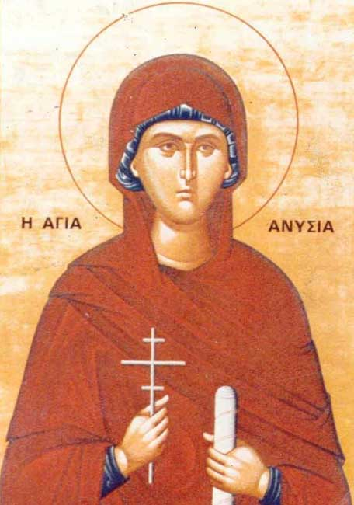
Our parish recently completed a cleaning project for the Nativity.
Every year, whether it's the Nativity or Easter, the Stewards of our parish look forward to this opportunity for fellowship. I reflected upon how as a parish and as Stewards, we could accomplish a large and at times, difficult task, by working together towards one common goal.
In our effort to beautify and prepare the Church, we also were able to build and grow our relationship in Christ.
As we face many challenges in our lives, let us always remember that through Jesus and our Church, we all become unified regardless of the differences we sometimes have. I pray that we can complete many more projects like this as I now better understand what the real benefit is.

